2X8D Sequencer Performance Specification
A Synthesizer Module

Signal Description
# | Signal Name | UI Element | Voltage Range | Signal Description
Step Specific UI
1 | Step Indicator | LED | - | Turns on when its step is active. If its step select is off, the LED doesn’t turn on.
2 | Step Select | Toggle Switch | - | Turn on to insert this step into the sequence. If on then CV, gate, and trigger outputs are generated for this step.
3 | CV Level | Pot | - | Controls the CV value during this step
Inputs
4 | Sequence Length | SP8T Rotary Switch | - | Can set from 1 to 8. If set to 6, the 6th step is the last one in the sequence. Then the sequence either stops or resets.
5 | Running Direction | 3 Position Toggle Switch | - | Outputs the sequence going forward, backward, or randomly. One for each channel.
6 | Octave | SP8T Rotary Switch (or 2 Push Buttons?) | - | The CV Level pots will only sweep through 3 octaves at once. This switch selects the octave that the pot starts at. One for each channel.
7 | Clock Rate | Coarse Pot and Fine Pot | - | How fast the sequence changes steps. In other words, the number of seconds each note is played before changing to the next one. Turning it faster makes it’s value increase by more for the same rotation distance.
8 | Clock Multiplier | SP8T Rotary Switch | - | Has settings 1/8, 1/4, 1/2, 1, 2, 4, 8, 16  In series mode:  In parallel mode: Affects the B sequencer clock rate based on the A sequencer clock rate, which can be from either an internal or external source.
9 | Step | Push Button | - | Moves the sequence forward one step. Useful when paused and programming it.
10 | Pause | Push Button | - | Pressing and letting go causes the sequencer to pause. Pressing again causes it to start.
11 | Gate Width | Pot | - | Lets the gate signal not last the entire length of the note, which lets the ADSR drop off before the end of the note.
12 | Exact Notes | Toggle Switch | - | When on, CV outputs will round to the nearest proper note based on 1V/octave.
13 | Exact Time | Toggle Switch | - | When on, Clock Rate will change by 1/8? second increments. Chose this value when testing.
14 | External Clock | Jack | 0V - 5V | Synchronizes the output to an external clock. Can probably do this in software with interrupts?
15 | Series/Parallel Select | Toggle Switch | - | Configure the sequencer as either two 8 step sequencers (A and B), or a single 16 step sequencer.
16 | Stop/Repeat Sequence | Toggle Switch | - | Stop: When the sequence is at the end, stop it. Needs to assert Reset to play again.  Repeat: when the sequence is at the end, start again from the beginning.
17 | Reset | Push Button and Jack | 0V - 5V | Starts playing the sequence from the first step.
18 | CV Max Level | Toggle Switch | - | Switch between 5V or 9V maximum voltage for CV Out.
19 | Portamento Rate | Pot | - | Controls how fast the voltage from Portamento Out changes when CV Out changes.
Outputs
20 | CV Out | Jack | 9V | Outputs a voltage that changes each step based on CV Level. 1V/octave. Does it go to 0 if step select is off?  One for each 8 step sequence. In series mode they output the same voltage.
21 | Portamento Out | Jack | 9V | Same as CV Out, but the CV slides between the last output level and the next one. This is done outside the microcontroller.
22 | Trig Out | Jack | 0 - 5V | Goes high for every active step for a very short time, something like 10ms.
23 | Gate Out | Jack | 0 - 5V | Stays high until a step is not active.

Portamento Description
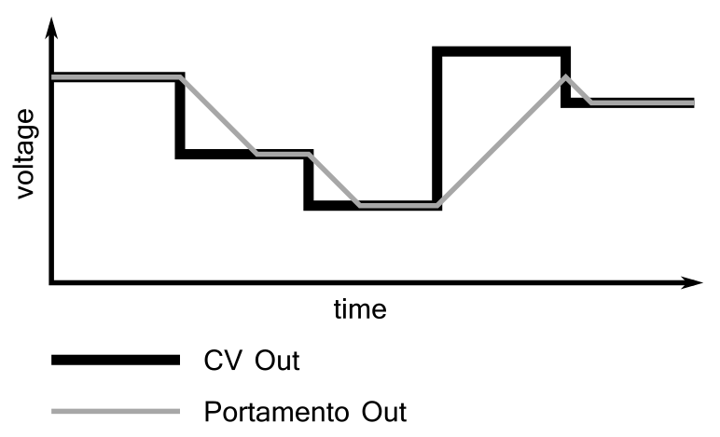
The Portamento Out output follows the CV Out output, but is limited to a certain slew rate. If Portamento Out doesn’t reach the CV Out level before it changes again, Portamento Out starts moving towards the new output level. The slew rate is adjusted by the Portamento Rate knob.

Block Diagram

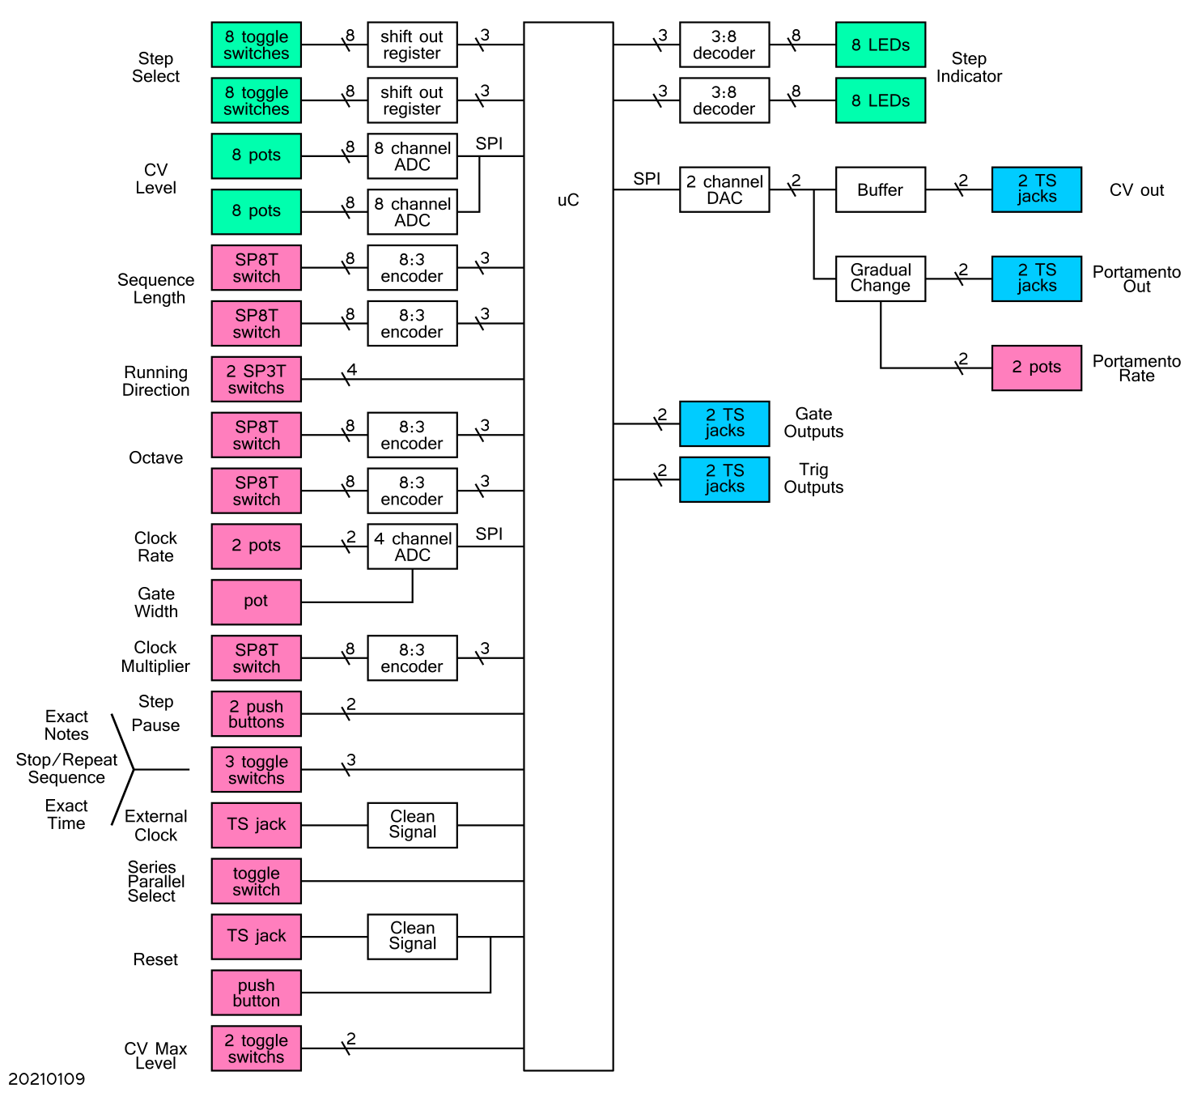
Rough Face Plate Layout
UI component position may change based on component size, logical grouping, or needing to put components of similar height together in order to be soldered to the same PCB.

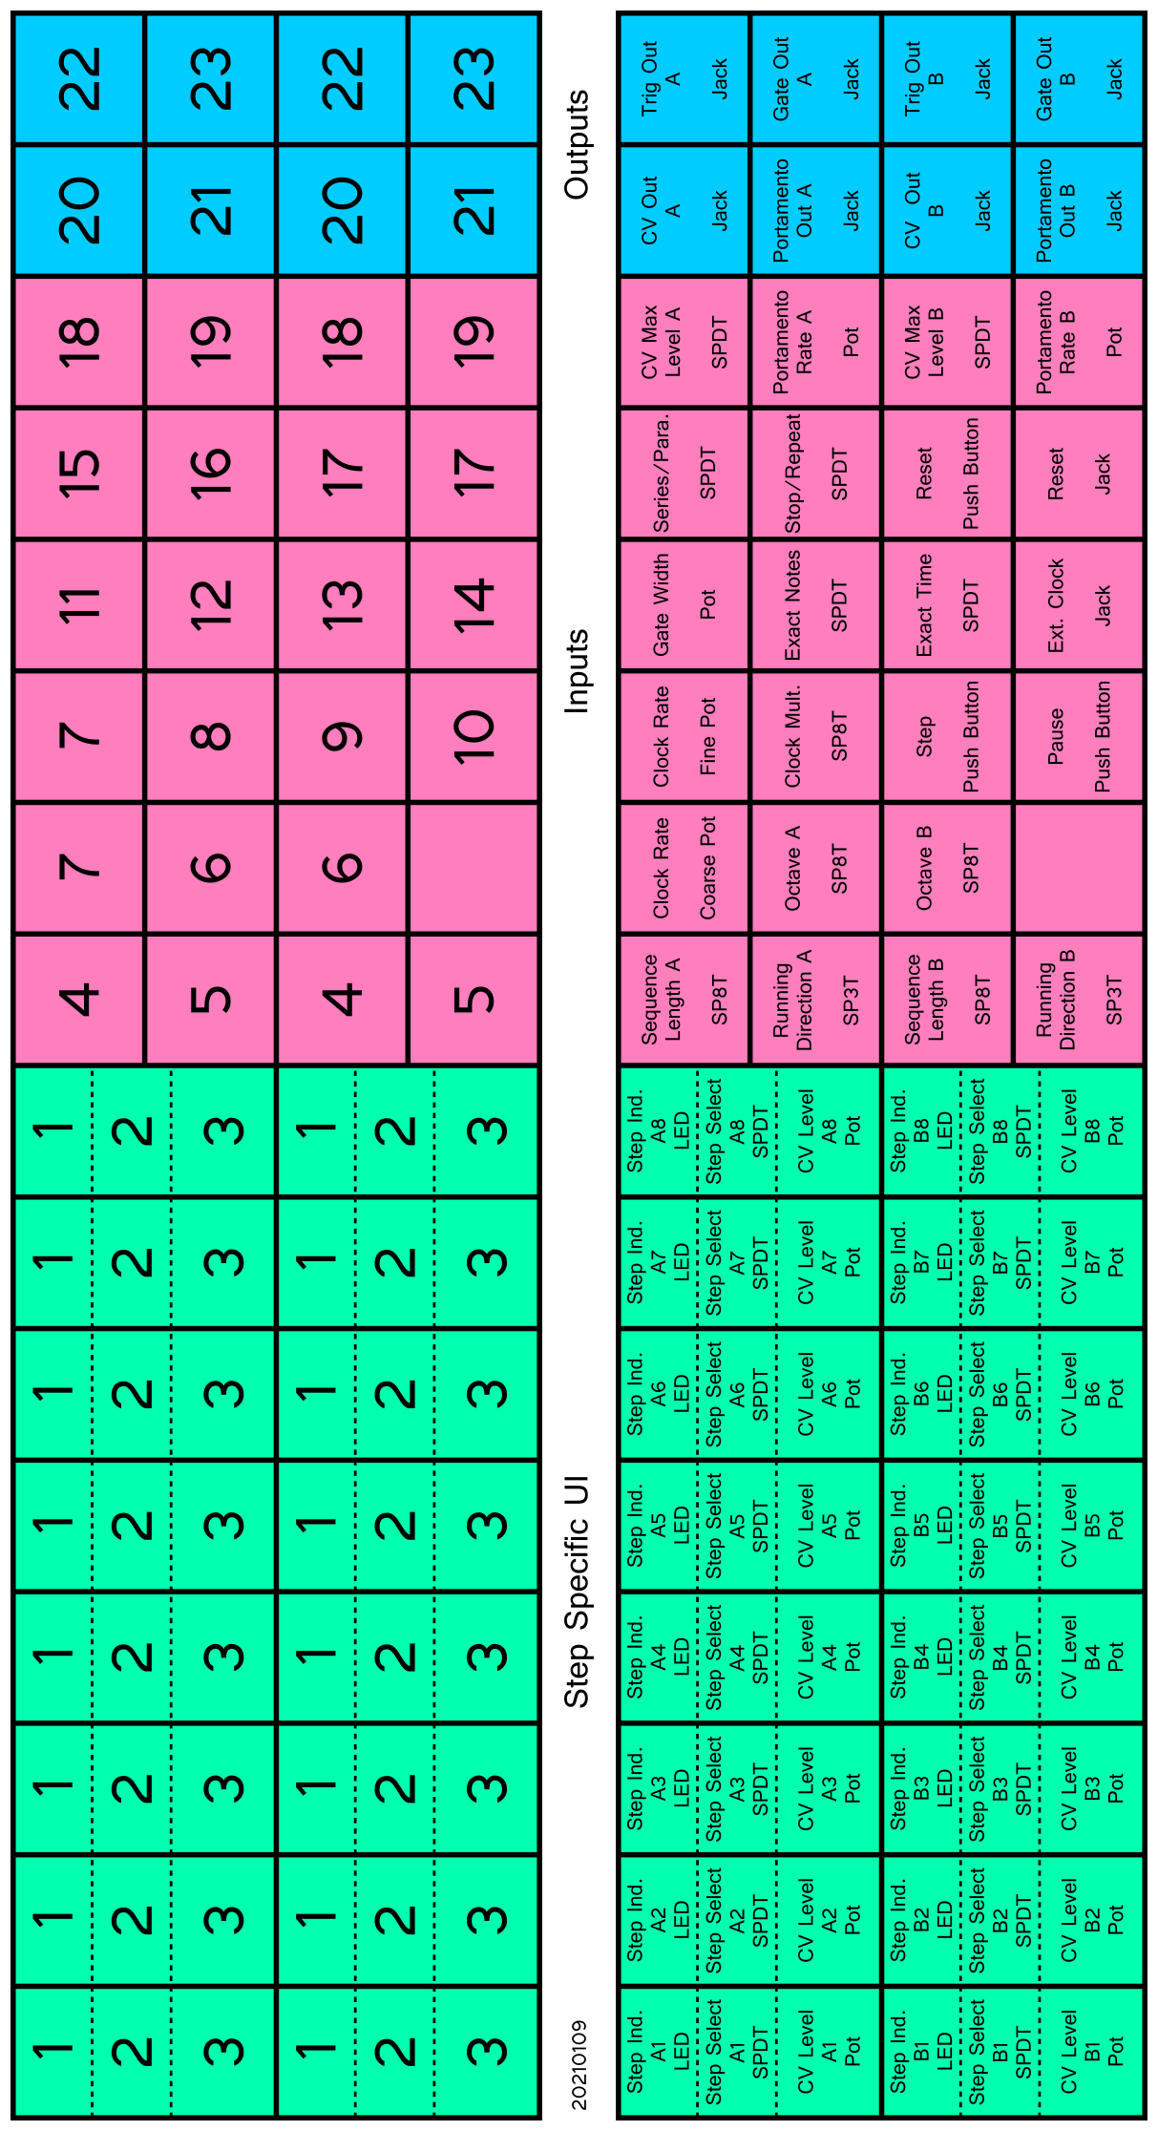
Microcontroller Behaviour
A lot of the controls can be read when the microcontroller needs them. However, some controls require the microcontroller to react to the immediately (bold entries in the following table).

Also, some behaviour could be different depending on if the sequence is paused (and the user is presumably tuning a step) or if it’s running. If you’re tuning the CV, the ADC should read just the current CV Level pot continuously.

The following table should be used to make block diagrams that define what the microcontroller does during each step.

# | Signal Name | UI Element | How Microcontroller Interfaces
Step Specific UI
1 | Step Indicator | LED | uC turns on the LEDs when needed.
2 | Step Select | TS | During each step, uC reads the Step Select switch for the next step. If off, read the next step after that. Continue until you find a step that’s on. Although given that all the switch data is shifted into the uC at once, individual reading for each switch aren’t needed.
3 | CV Level | Pot | The next step’s value is read during the previous step so it’s ready to go when needed.
Inputs
4 | Sequence Length | SP8T | Read every step.
5 | Running Direction | 3 Position TS | Read at the start of a sequence.
6 | Octave | SP8T | Read every step.
7 | Clock Rate | 2x Pot | Read every step.
8 | Clock Multiplier | SP8T | Read every step.
9 | Step | PB | uC reacts immediately when asserted.
10 | Pause | PB | uC reacts immediately when asserted.
11 | Gate Width | Pot | Read every step.
12 | Exact Notes | TS | Read every step.
13 | Exact Time | TS | Read every step.
14 | Ext. Clock | Jack | uC reacts immediately when asserted.
15 | Series/Parallel | TS | Read every step.
16 | Stop/Repeat | TS | Read at the end of either sequence.
17 | Reset | PB + Jack | uC reacts immediately when asserted.
18 | CV Max Level | TS | uC reacts immediately when switched. It might be possible to not involve the microcontroller in this function.
19 | Port. Rate | Pot | Not connected to microcontroller.
Outputs
20 | CV Out | Jack | Microcontroller programs the DAC at the start of every step.
21 | Port.Out | Jack | Not connected to microcontroller.
22 | Trig Out | Jack | Microcontroller changes the GPIO as needed during each step.
23 | Gate Out | Jack | Microcontroller changes the GPIO as needed during each step.

Notes
All inputs must tolerate -12 to +12 V input signals without distorting the signal. i.e. if you plug a 12V trigger signal into the Reset input, the trigger signal must still go up to 12V, not saturate at 5V.

From https://learningmodular.com/glossary/impedance/
Eurorack modules tend to have an input impedance of 100 kΩ ; output impedances can vary from near zero to 1k.

Here I’ll follow the MFOS sequencer and use a 220 Ω resistor in series with each output. At 12V this gives a current of 55 mA when the output is shorted to ground. (Make sure outputs are rated to at least 55 mA or increase resistance). When fed into an input impedance of 100 kΩ, 99.8% of the voltage will be across the input impedance.

https://www.muffwiggler.com/forum/viewtopic.php?t=12112
This forum thread claims output impedances are usually 1 kΩ, which gives 12 mA at 12 V:

The CV level pots don’t sweep over the full output range. That would make them very sensitive and hard to tune. Most songs only have a pitch range of 1 – 3 octaves, so 3 octaves will be the range the CV Level pots can sweep over. There’s 12 notes/octave, so the pot will have 36 different states. 5 bits encodes 32 states. 12 bits encodes 4096 states. With a 12 bit ADC, each note covers 4096/36 = 113 states, which is better than 1% of a note. Therefore a 12 bit ADC is sufficient.

The MIDI range covers octaves -1 to 9, or 11 octaves. For the 8 position octave switch, setting it to position 8 will let the CV Level pots sweep through octaves 8 – 10. That doesn’t cover the full octave range. I’d rather have a range of (16.35 Hz – 12.5 kHz) than (8.18 Hz – 7.9 kHz). So we’ll cover octaves 0 – 9.

Pots have a rotation distance of 300 degrees. For 3 octaves, that’s 300 / (3*12) = 8.33 degrees/note:



A moderately sized knob should make it easy to change notes that angle apart. For comparison, having the knob sweep over all 11 octaves gives 2.27 degrees/note:

Construction
The mechanical stack up is face plate, then UI components, then UI component PCBs, then headers to electronics PCBs.

Design should enable replacing electronics very easily. Don’t put electrical components (ICs, caps, transistors, ect.) on UI component PCBs. Those PCBs are there to reduce soldering time. If the electronics on the UI component PCBs break then you’ll either have to unsolder all the UI hardware (time consuming) or buy new UI hardware (expensive).

On the face plate, put the individual step control stuff, then inputs, then outputs. Signal flow should go from left to right. This module will be in the top left of the rack, so this lets all the jacks be to the right to reduce cable length.

Maybe I can get pots with illuminated stems. Would have to use them with clear knobs, because turning just the pot stem doesn’t give fine enough control.

Very Rough Cost Estimate
Item | Cost
ICs | $35
UI Hardware | $30
PCBs – JLC PCB | $10
Import Fees – JLC PCB | $10
Per Unit Cost | $85

Add appendix with Note information table

